Design
Competency
Statement
Revision history
Revision | Date | Description | By | Checked
A | 01.10.2023 | First Issue | BC | TS

Contents
Experience 2
Knowledge base 2
Maintaining and developing knowledge 3
Capacity and skillset 3
Behaviour 4

Experience
BoonBrown, established in 1986, boasts a rich portfolio of over 2000 projects spanning various work stages, sectors, scales, and complexities. In the past 20 years, BoonBrown have tackled 12 challenging projects exceeding 18m, all classified as Higher Risk Buildings. Notably, BoonBrown led the design process (RIBA stages 4-5) for these complex undertakings. This extensive experience translates into a highly skilled team, evidenced in 2023 by:
Out of 32 professional architectural staff team members.

37% are ARB Registered | 28% have at least 12 months experience of RIBA Stage 3-5 on buildings over 18m | 43% have at least 6 months experience of RIBA Stage 3-5 on buildings over 18m

Knowledge base
Deep roots run through BoonBrown, with a significant portion of our staff and management holding over a decade of experience within the practice, providing continuity and confidence in every project. 21% of our talented team and a resounding 56% of our leaders have been with us for over 10 years, ensuring a legacy of knowledge and collective expertise that fuels our future endeavours.
BoonBrown completed 2023 with a talented team of 47 individuals, comprising:
- 12 architecturally registered professionals: These ARB-registered architects bring a wealth of experience to the table, ensuring your project meets all necessary design and construction standards.
- 2 landscape architecture experts: From master plans to intricate garden details, these Landscape Institute-registered professionals can make your outdoor spaces truly shine.
- 2 skilled town planners: With RTPI registration under their belts, these individuals understand the bigger picture, ensuring your project integrates seamlessly with the surrounding community.
Supporting this core group are 26 additional team members:
- Architectural, landscape, and town planning staff: This dedicated group, including those pursuing professional registration, provides invaluable assistance across all project stages.
- Technologists and technicians: These specialists leverage their technical expertise to bring your vision to life, tackling challenges big and small.
Behind the scenes, a robust technical leadership team keeps everything running smoothly:
- 2 experienced technical directors: Each with a diverse project portfolio, these individuals provide expert guidance and ensure every project meets the highest standards.
- 3 knowledgeable technical associates: Offering additional support and mentorship, these professionals ensure the team has the resources and expertise they need to succeed.
Each member of the technical management team is involved in the auditing of BoonBrown projects at key RIBA milestones and actively mentor and support the project staff on technical matters.

Maintaining and developing knowledge
Investing in our people, we prioritise continual professional growth with a diverse CPD program featuring a variety of topics aligned with the RIBA Core Curriculum. All sessions are recorded and made available to all staff via an online library, empowering them to stay updated and refine skills.
Individual training needs are regularly assessed, any skill or knowledge gaps identified, and a personal development pathway set out, tailored to the individual. Training can take various forms, internally arranged or externally sourced, time allowance for study to sponsorship of course fees.
Furthermore, bulletins relating to industry hot topics, regulatory updates, or project specific instances are issued monthly office wide.
As the RIBA/ARB competency program evolves, we wish to align our staff development with its standards, and we intend to seek assessment utilising third-party accreditation.
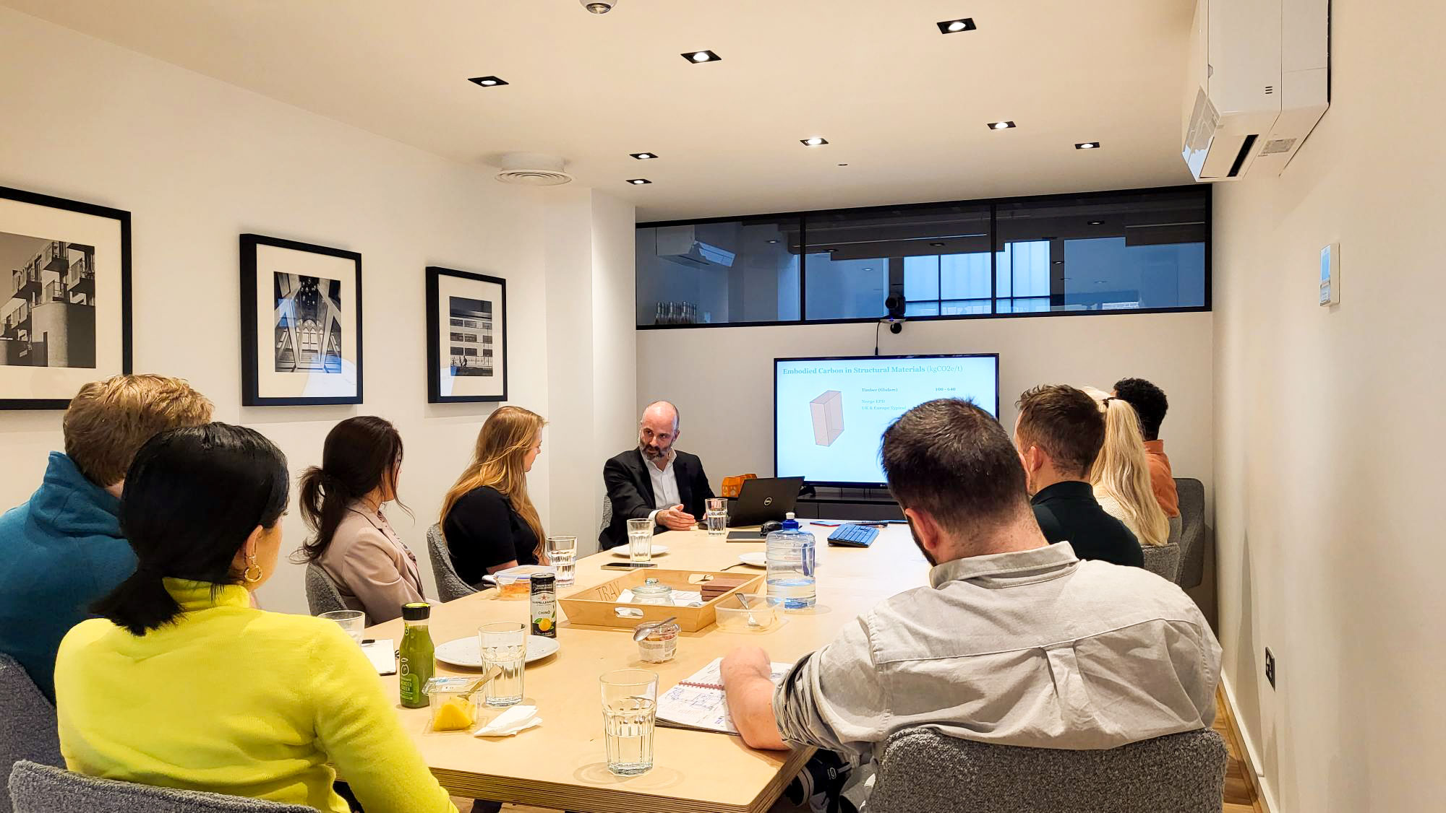

Capacity and skillset
Each team within the practice hold weekly meetings to review current project commitments and any requirements for additional skillset or resource that may be required to ensure programme and quality of output are achieved. Furthermore, the team’s capacity and skillset are reviewed for any new projects, and where necessary, discussed further with the wider practice.
The Architectural training our staff have received, and the live project experience they have gained, provide the problem-solving, inquisitive, and analytical skillset required to successfully deliver our projects.
We believe the successful delivery of great architecture is the result of synergy within the overall design team. Our staff have very strong interpersonal skills, are good communicators and collaborators, and have the skillset to manage and to lead the coordination of input from all design team members to ensure a fully cohesive and compliant output.
Our teams are provided external and internal training to develop the appropriate skills in the use of a variety of 3D software packages, which not only encourages creative design flexibility but further enhances our ability to coordinate our project designs.
We encourage individuals to raise any concerns they have about limits of the skillset or capacity. In these instances, we review whether the individual should be provided with additional training, with mentoring and supervision, or whether the work should be reallocated to a suitably skilled and capable member of staff.

Behaviour
As an RIBA Chartered practice, we seek to ensure our Architects adhere to the RIBA Code of Practice and comply with RIBA Continuing Professional Development obligations. This code of practice is extended to all BoonBrown staff.
BoonBrown will only accept a commission if we are confident, we have the capacity, the knowledge, skillset, and experience to do so. If the management team feel that one of these areas is not being met to fulfil the project, we will endeavour to rectify through training and recruitment where possible. If is it considered that a project is beyond the practice’s capabilities, the work shall be declined.
The practice promotes an ethical approach in all areas of the business, with openness and collaboration the forefront of our mission statement. We operate a culture of proactive safety and risk mitigation. This proactive approach allows our innovative design output to flourish within a secure and responsible framework.
BoonBrown offer both Principal Designer (CDM) and Principal Designer (BRAE) services in parallel with our core services of Architecture, Town Planning and Landscape Architecture.
This document will be reviewed annually and amended to reflect any relevant legislative changes.

Tim Shepperd
Technical Director | BoonBrown Ltd

